# USE CASE

# COMPONENT DIAGRAM

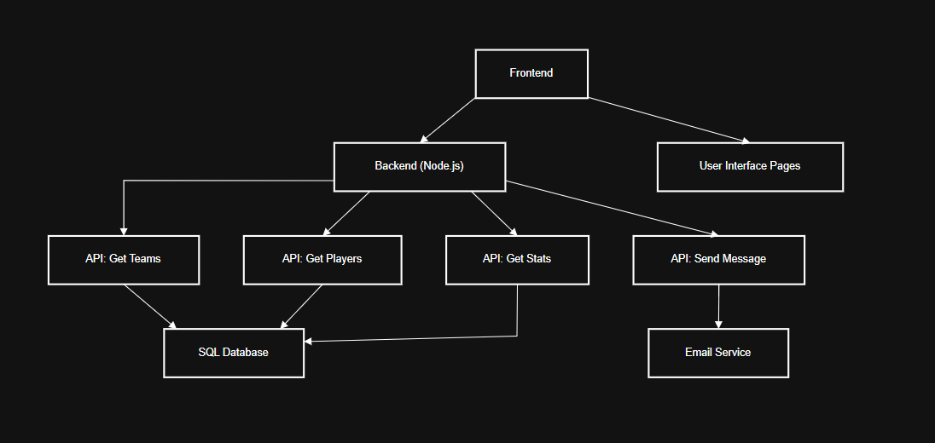

# DEPLOYEMENT DIAGRAM

# CLASS DIAGRAM

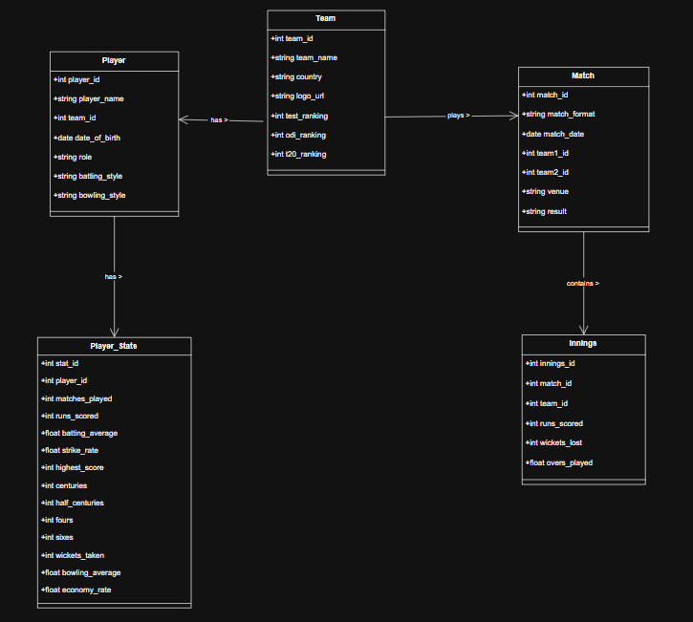

# SEQUENCE DIAGRAM

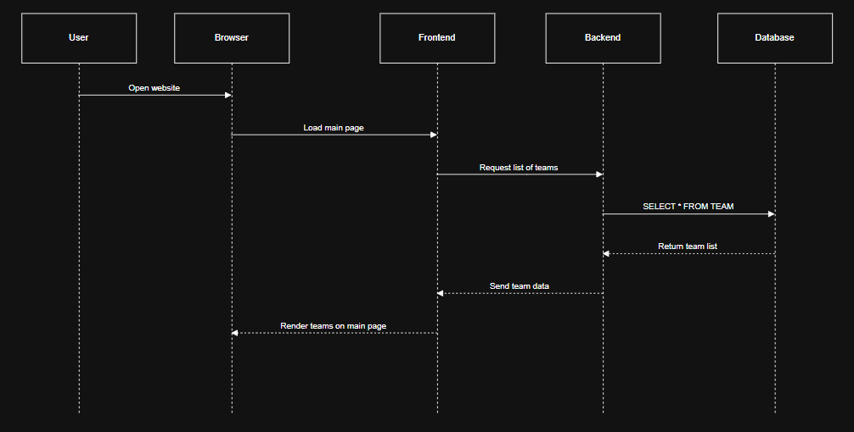

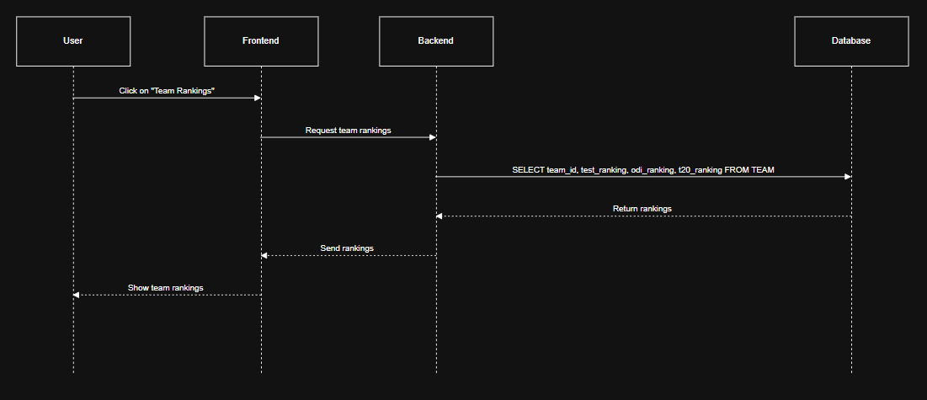

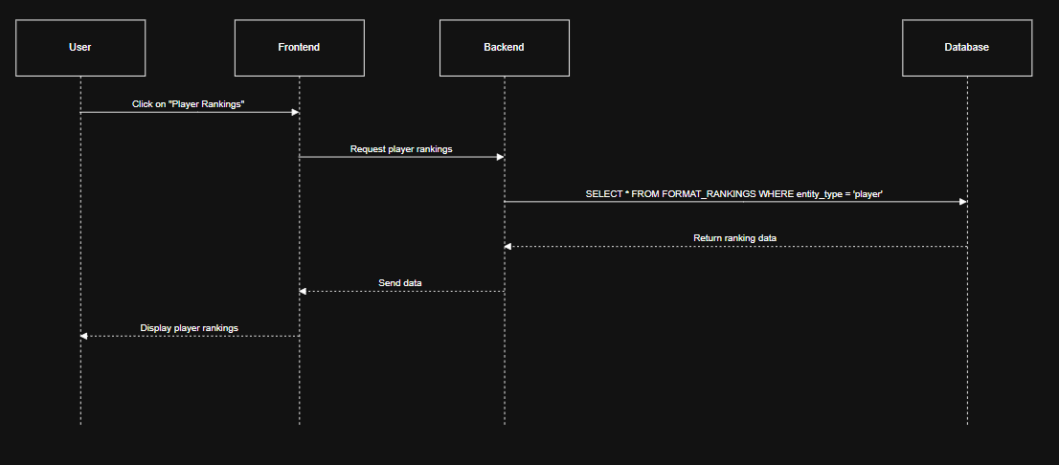

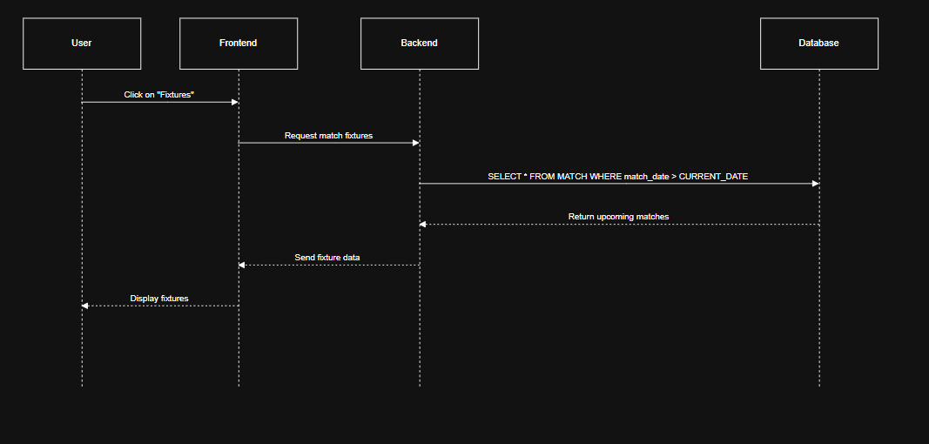

# ACTIVITY DIAGRAM

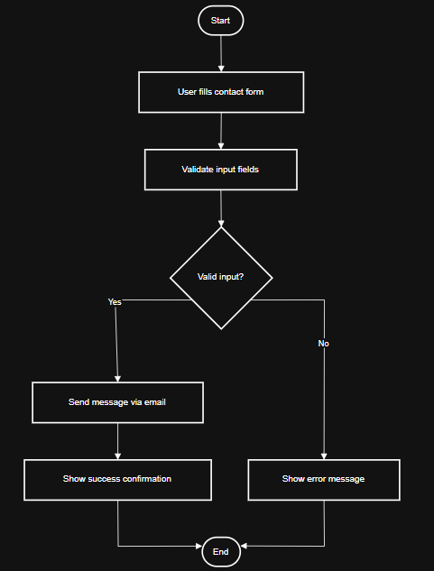

# STATE TRANSITION DIAGRAM